“Father’s Wrongs”
By Ben Atherton-Zeman
With Lorien Castelle and Casey Keene
August, 2007

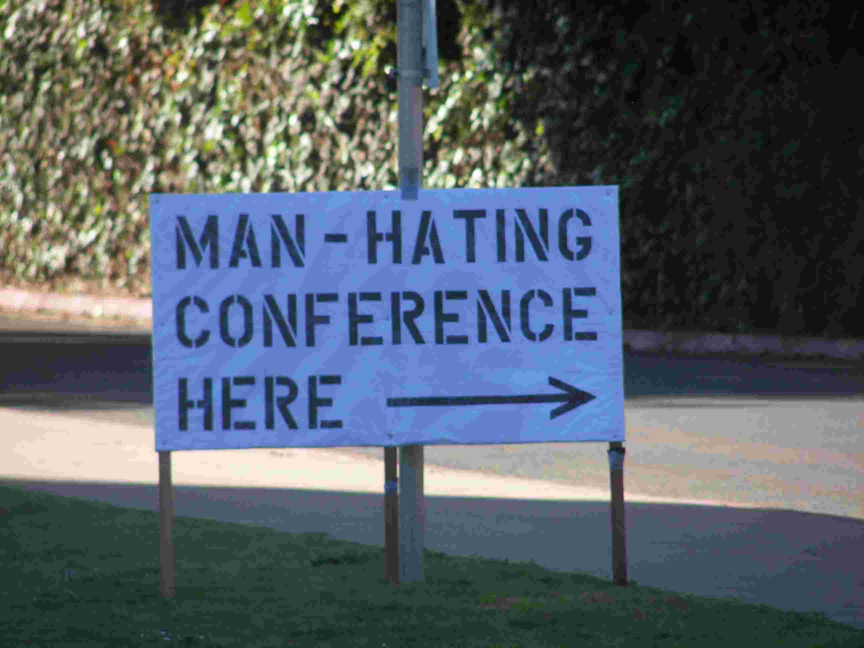
I was thrilled to perform my one-man play, “Voices of Men” for the San Diego Men’s Leadership Forum. I flew to San Diego and was driven to the auditorium where the event was to take place – my hosts told me there would be over 300 men in attendance, many of them from the nearby military base. All the men had committed themselves to taking the initiative to stop men’s violence against women.

As my host drove us up to the event, it became clear we were not the only group of men there. I was greeted by signs saying “Man-Hating Conference Here,” “Domestic Violence Law is a Feminist Scam,” and “Save Our Troops from Feminist Man-Hating.”

A large group of men (and some women) had gathered along the street and outside our venue. They had over 20 large, expensive signs and a huge RV with messages airbrushed onto it. They had brochures they were passing out. They had brought food. They were organized.

I had some time before my performance, so I went to meet them and take some photos. Some were chatty and friendly – some were downright scary, glowering and silent. I got a tour of the RV from a proud father who showed me where his son had painted part of the outside. Many were eager to speak to me about their philosophy – they encouraged me to “keep an open mind” and not be brainwashed by feminists.
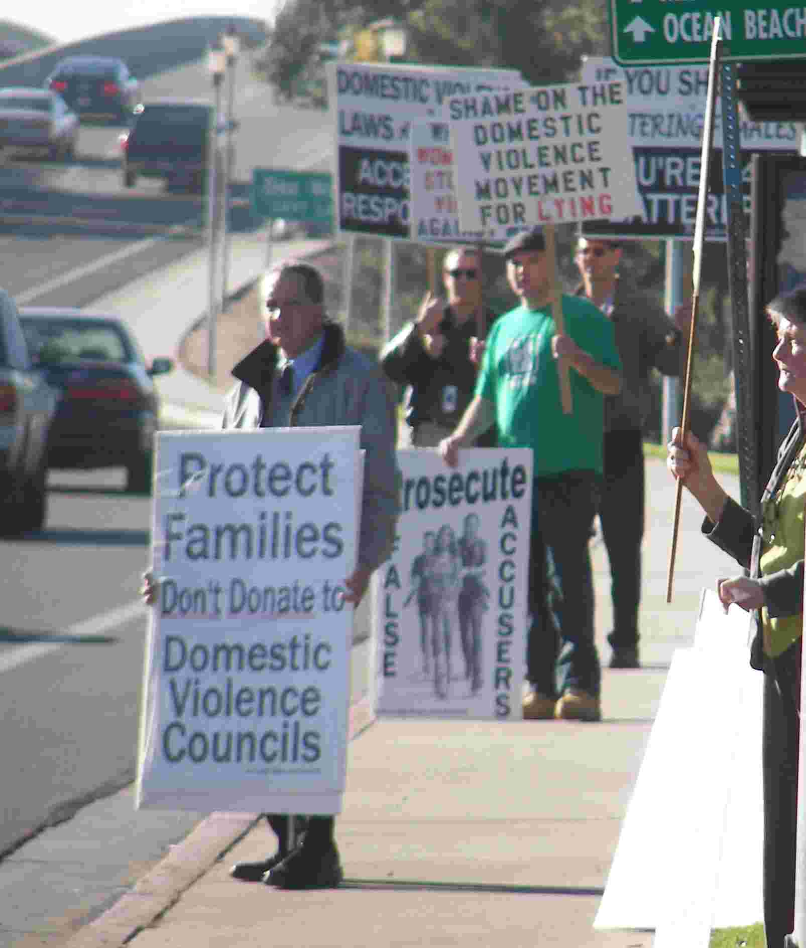
I’ve been working to end men’s violence for almost twenty years. I have encountered the so-called “Father’s Rights”* movement in the past (as well as their sexual assault predecessors, the so-called “False Memory Syndrome” folks). Usually, my encounter consisted of one or two guys who came to state legislator hearings, wearing suits and ties, to testify on a custody bill. They would make an impassioned plea to get legislators to “recognize fatherhood to be as important as motherhood.” But usually they shot themselves in the foot – they were socially awkward, would invade the personal space of legislators (and the rest of us), and ended up spouting rhetoric that made them seem like extremists. Legislators’ initial sympathies waned once they saw what these guys were really like.

-------------------------------------------------------------------------------------------------------------------------------
* In this essay, I use the term “so-called ‘Father’s Rights’” because I do not believe these groups’ goal is to promote the rights of fathers. Their intent is to promote father’s rights, but the effect of their words and actions are to eradicate the goals of the movement to end men’s violence against women. In my opinion, feminism is the real “father’s rights” movement. Feminists advocate for shared parenting, shared responsibility, economic equality, and an end to all violence and oppression – goals that are certainly liberating and beneficial for any father.
After these initial encounters, I asked feminist leaders I knew what they thought we should do. Their advice was to ignore these guys. Any statement we put out to the public concerning them would only grant them unearned attention. I gladly complied – we were busy enough with other concerns.


Sadly, the time has come when we can no longer afford to ignore them. “Father’s Rights” members have stalked and harassed advocates, sent threatening emails and letters, and lobbied Congress to change the name of the Violence Against Women Act. Certainly, there are communities where these folks are few and disorganized – ignoring them might still be the best option. But we need to prepare other options – I am certainly no expert, but have some ideas that we might want to consider.

War is Peace – Up is Down

Why are more and more fathers (and their wives/girlfriends/female friends) joining these groups?

Consider other “backlash” movements: the Ku Klux Klan, Nazis, anti-choice activists and the already-mentioned “False Memory Syndrome” folks. Each of these movements has been organized on one Orwellian hypothesis – they are the real victims. Not people of color – white people who have had “their” jobs and “their” women taken away. Not Jews, GLBT folks, Romani and people with disabilities – the Germans and whites who are “polluted” by these folks even existing. Not victims of child rape – the poor men who are “falsely accused” of raping their kids. Not women seeking reproductive freedom – poor defenseless babies and fathers who are shut out of reproductive decisions (see Ohio’s bill mandating the “father’s” consent in any abortion decision, even when the father is completely out of the picture).

Those of us who give educational presentations on men’s violence against women are familiar with this defense. Boys and men, confronted with the statistical reality of men’s violence, will do anything to avoid the realization that our gender is predominantly responsible for this violence – argue the statistics, point out anecdotal evidence of women’s violence against men, or “shoot the messenger” by mocking or belittling the (usually female) trainer giving the presentation.

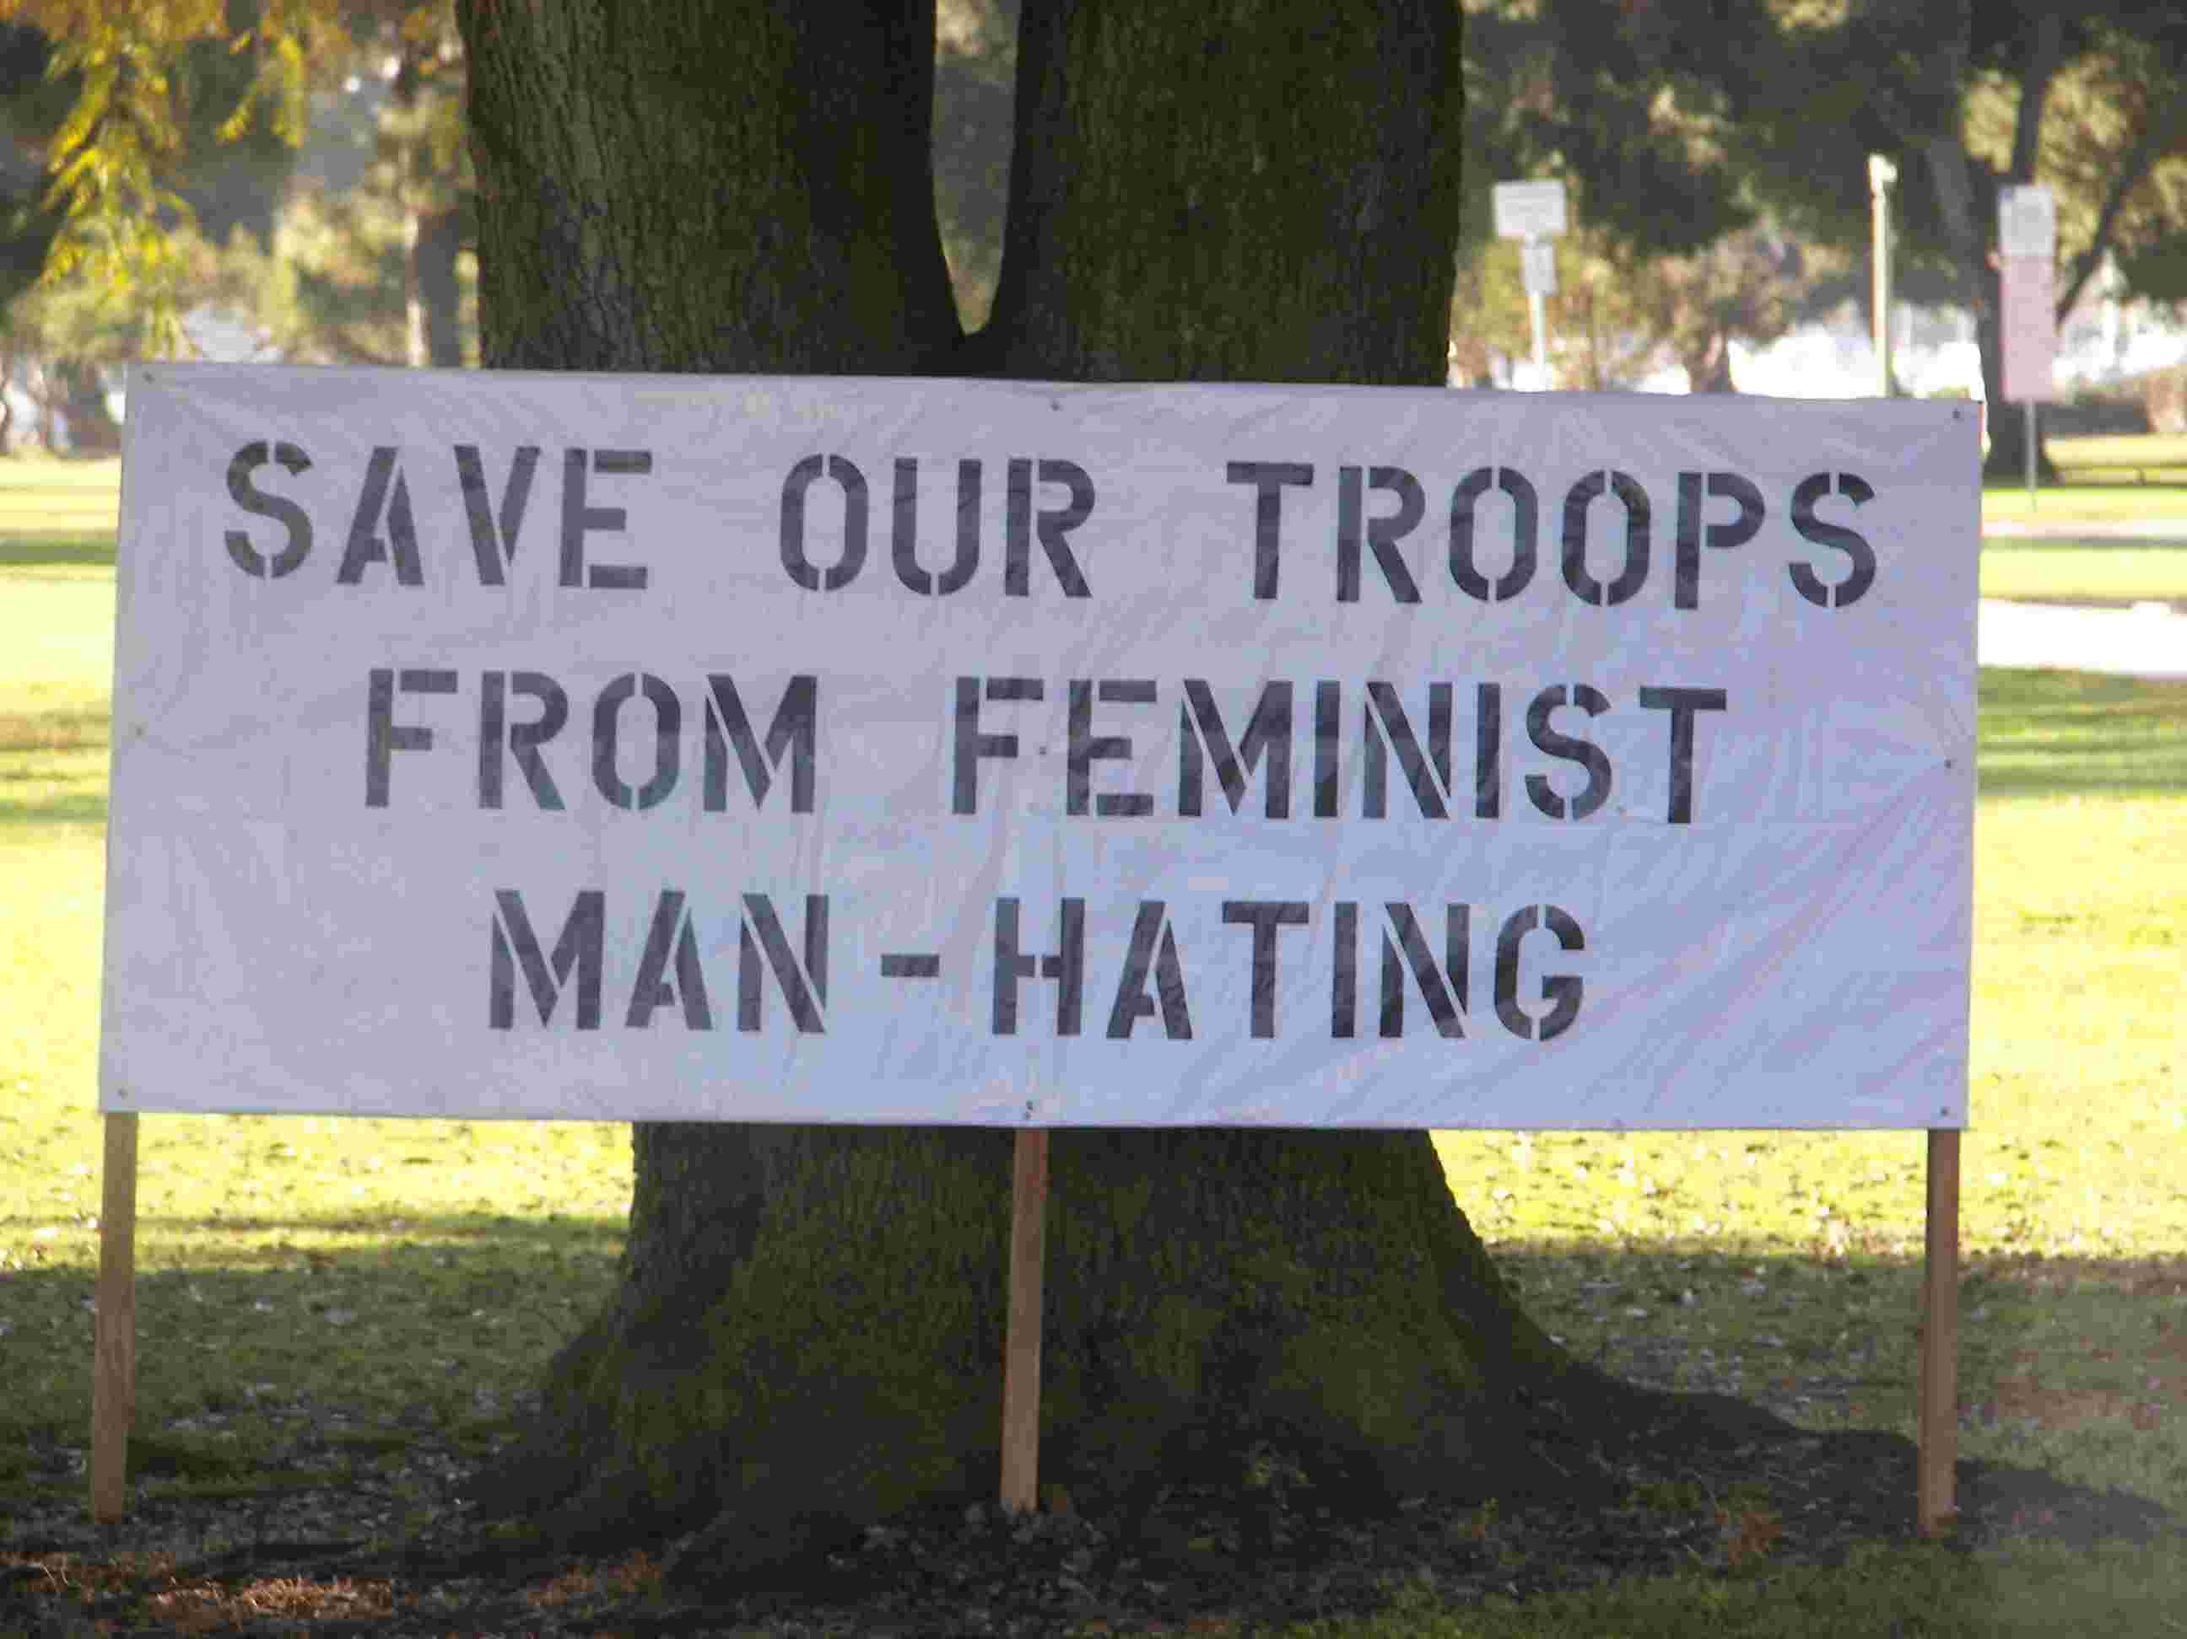
Honestly, I can relate to this: when my wife Lucinda points out a way in which I’ve unintentionally hurt her, my first response is to usually deny that I’ve done anything wrong, or explain to her why she shouldn’t feel hurt in the first place. It’s a painful thing to admit I’ve been a party to hurting someone I love – I’d rather the hurt hadn’t taken place in the first place. But eventually, I get around to admitting that I participated in hurting Lucinda – only then am I a useful partner in terms of changing things so I don’t hurt her again.

Many men avoid that step. Like batterers who deny individual responsibility for violence, many men deny the responsibility of our gender’s violence.

Certainly, most men have been confronted with the painful realization that men’s violence against women is a huge problem, due to the success of the educational campaigns of the feminist movement against men’s violence. The inevitable conclusion is that we men must take the initiative to stop such violence. But if these men are offered an easier way out – if they are the actual victims of a hegemonic feminist conspiracy – if the court system is biased against men and fathers, then they can revel in self-righteous victimhood.

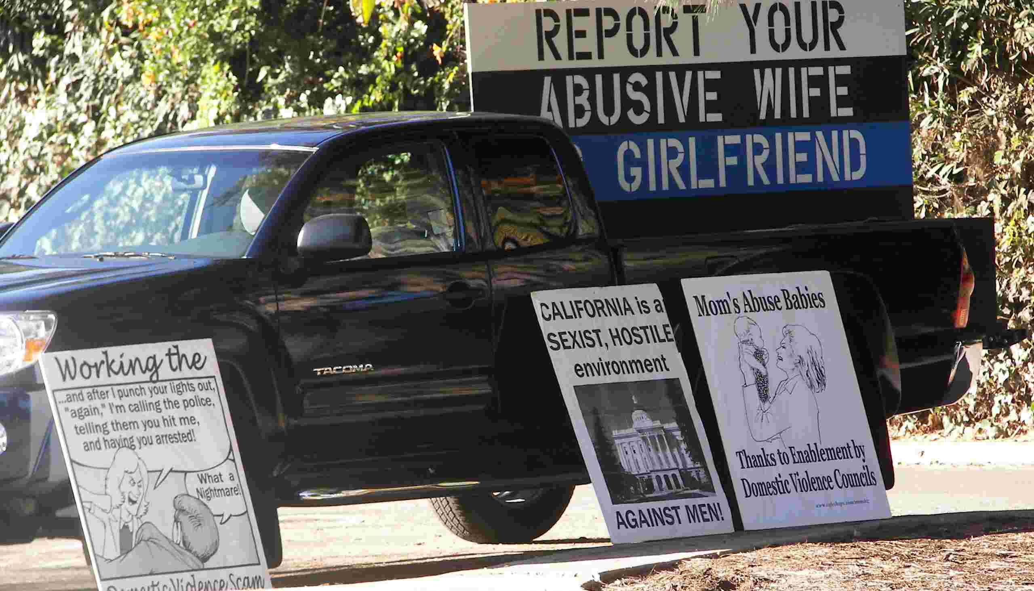
As a gender, men have been offered these “easy outs” in the past. In the 70’s, confronted with the second wave feminists’ challenging of gender roles, some men responded by creating the profeminist men’s movement. Many more joined the so-called “Moral Majority” and its antecedents like the “Promise Keepers.”*

Men who observe feminists challenging traditional gender roles usually wonder what their response should be, now that these roles have changed. The feminist and profeminist men’s movements offer a difficult answer, yet one that is more rewarding in the long run: our role as men of conscience is to be as brave as feminist women have been, examining all that we have learned about being male, being in a relationship, being a father. “Promise Keepers” and other right-wing groups offered an easy answer – Our role is to reclaim our place at the head of the traditional family.

So-called “Father’s Rights” groups are a continuation of this pattern of turning privilege into victimhood. More than simply a backlash, these groups are a way to avoid dealing with painful realizations about privilege and entitlement. Instead, they allow – even encourage – the childish “But she hit me, too!” response. They use popular, easy to understand phrases to lure men and women into their membership ranks – men and women that I believe we could reach instead.

The Emperor Has No Clothes

Rallying cries by the “Father’s Rights” groups crumble under an even cursory examination. By shedding the harsh light of day on their assertions, we will also find ways to combat these groups in our communities.
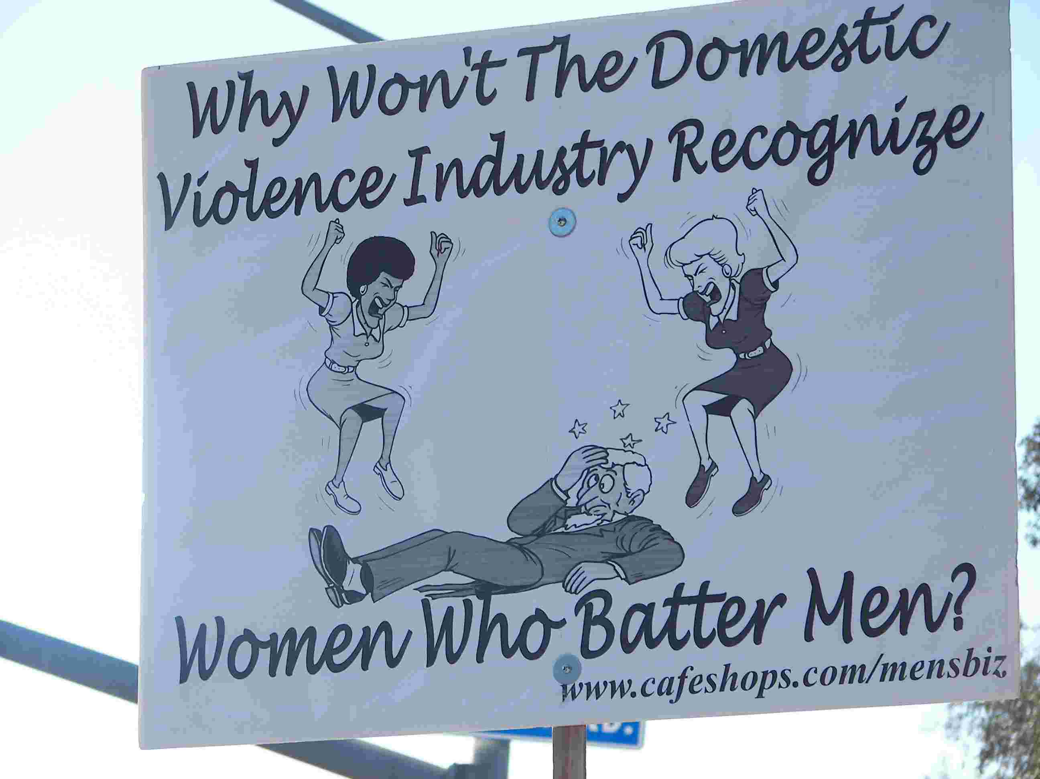
Myth #1: Men Are Abused Just As Much As Women (And Feminists Protect Our Huge Salaries by Covering This Up)

Reality #1: Virtually every study published about domestic violence and intimate partner violence shows that men are the predominant aggressors in most cases. The one study that does not – the Straus and Gelles study from the 1980s – has been assailed by academics as “bad science, with findings and conclusions that are contradictory, inconsistent, and unwarranted (Jack Straton, “The Myth of the ‘Battered Husband’ Syndrome,” http://www.nomas.org/node/107).”

-------------------------------------------------------------------------------------------------------------------------------
*Again, I use quotes for these groups since the “Promise Keepers” do not, in my opinion, “keep” their “promise” of a better family life since, at the core, they espouse stifling and harmful gender roles with the husband as the undisputed head of the household. And, as the old bumper sticker says, “The Moral Majority Is Neither.”

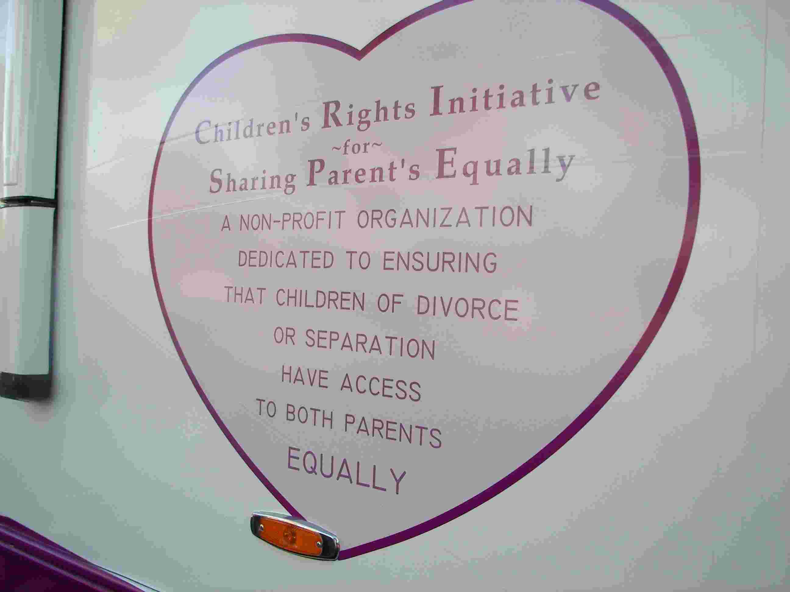
This doesn’t stop the “Father’s Rights” groups from pulling out this study like an old shoe at every legislative hearing – they use this tactic not to care for men who are abused, but to further their own political goals (see articles below for more info on Straus and the Conflict Tactics Scale).

Indeed, there are male victims of both sexual assault and domestic violence – most Father’s Rights” groups fail to note that

Strategies: Those of us who work with victims of domestic violence know that there are plenty of bona fide male victims – gay, bisexual, transgender and straight. In fact, there is a greater likelihood of male victimization in gay male relationships than in heterosexual ones (see articles below).

Ironically, and contrary to what the “Father’s Rights” groups say, the battered women’s movement is still the best place to go for most abused men. We help men every day with court advocacy, one-on-one counseling, hotline assistance, and even shelter and support groups in some cases. We can be proud of this as a movement – we can talk publicly about our services to men. And we can improve those services, to men and to all people, and create targeted outreach campaigns to male victims and other special populations.

We also know that virtually all men who batter identify as the “victim” at some point. The general public will understand this due to familiarity with batterers and other criminals – their pleas of innocence and victimhood will ring hollow in most ears if they have been convicted of wife or child abuse.

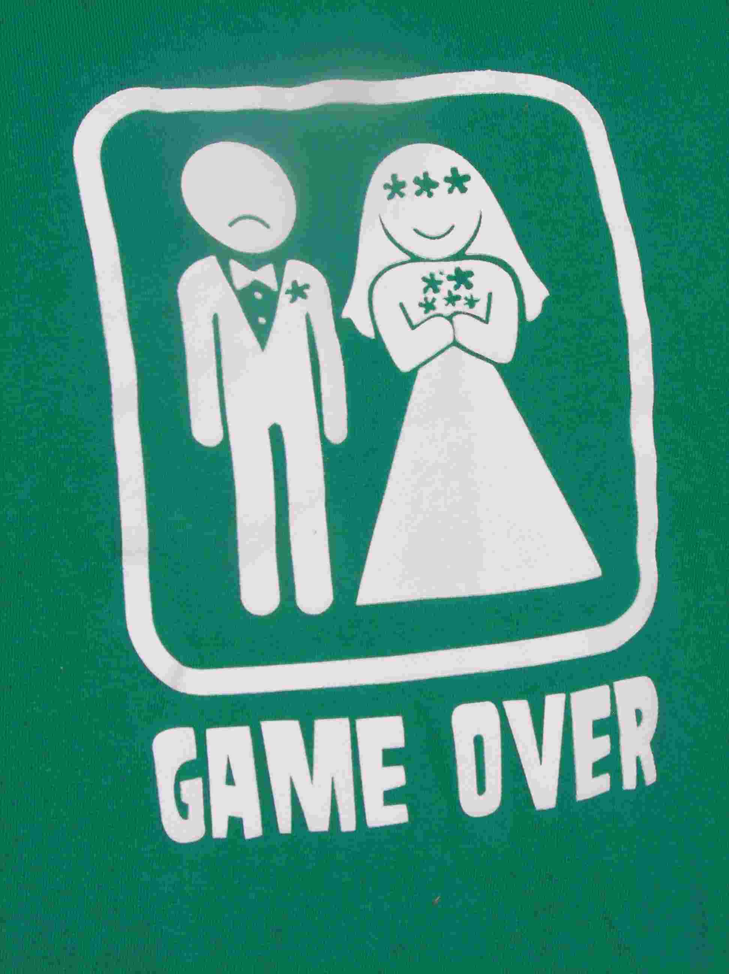
Finally, we can be ready for the ritual hauling out of the Straus and Gelles studies. We can be ready with other scientific studies – our state coalitions can provide us with well-researched, documented facts and figures about our communities. Or print out some of the articles from VAWNet below.

Myth #2: Our Slogans Are Harmless, and So Are We

Reality #2: “Father’s Rights” groups use slogans that most legislators believe. The RV I was shown spoke of the “Children’s Rights Initiative – A Non-Profit Organization Dedicated to Ensuring That Children of Divorce or Separation Have Access to Both Parents – Equally.” (see photo, left) Sounds reasonable, right? Like much of the right wing, they are good at framing right-wing ideas with a centrist label (remember “pro-life”?). But if you dig under the mild slogans, you will find harmful and often violent underpinnings – look for these other slogans and bring them to light.

Strategies: Bring printouts of T-shirts (below right) and quotes from “Father’s Rights” websites to legislative hearings where these folks will be present – they won’t look so mild-mannered once you quote them.
T-shirt worn by “Father’s Rights” member

These groups are also deft at framing our causes as extreme (remember “partial-birth” abortion, “feminazi”?). If I knew nothing about our movement to end men’s violence and I drove by this demonstration in San Diego, it might have scared me away from feminism and from the domestic violence movement. We have to be ready with reasoned argument, framed as soundbites as pithy as these signs.

Finally, many of the leaders (and followers) in these movements will have criminal records. They will claim that this is because they’ve been wrongly prosecuted by lying women supported by feminists – but they’re still convicted wife-beaters. Pointing this out might make them seem less sympathetic.

Myth #3: The Court System is Run by Feminists, and is Biased Against Men

Reality #3: Many of us work with battered women (not to mention rape victims) who are not believed, who are not granted restraining orders, and who are systemically isolated by a criminal justice system and a society that does not believe them. For child custody, it is true that cases are decided in favor of the mother – that’s because in many cases, the father doesn’t want custody! When the father wants custody, the decision is in his favor the majority of the time.

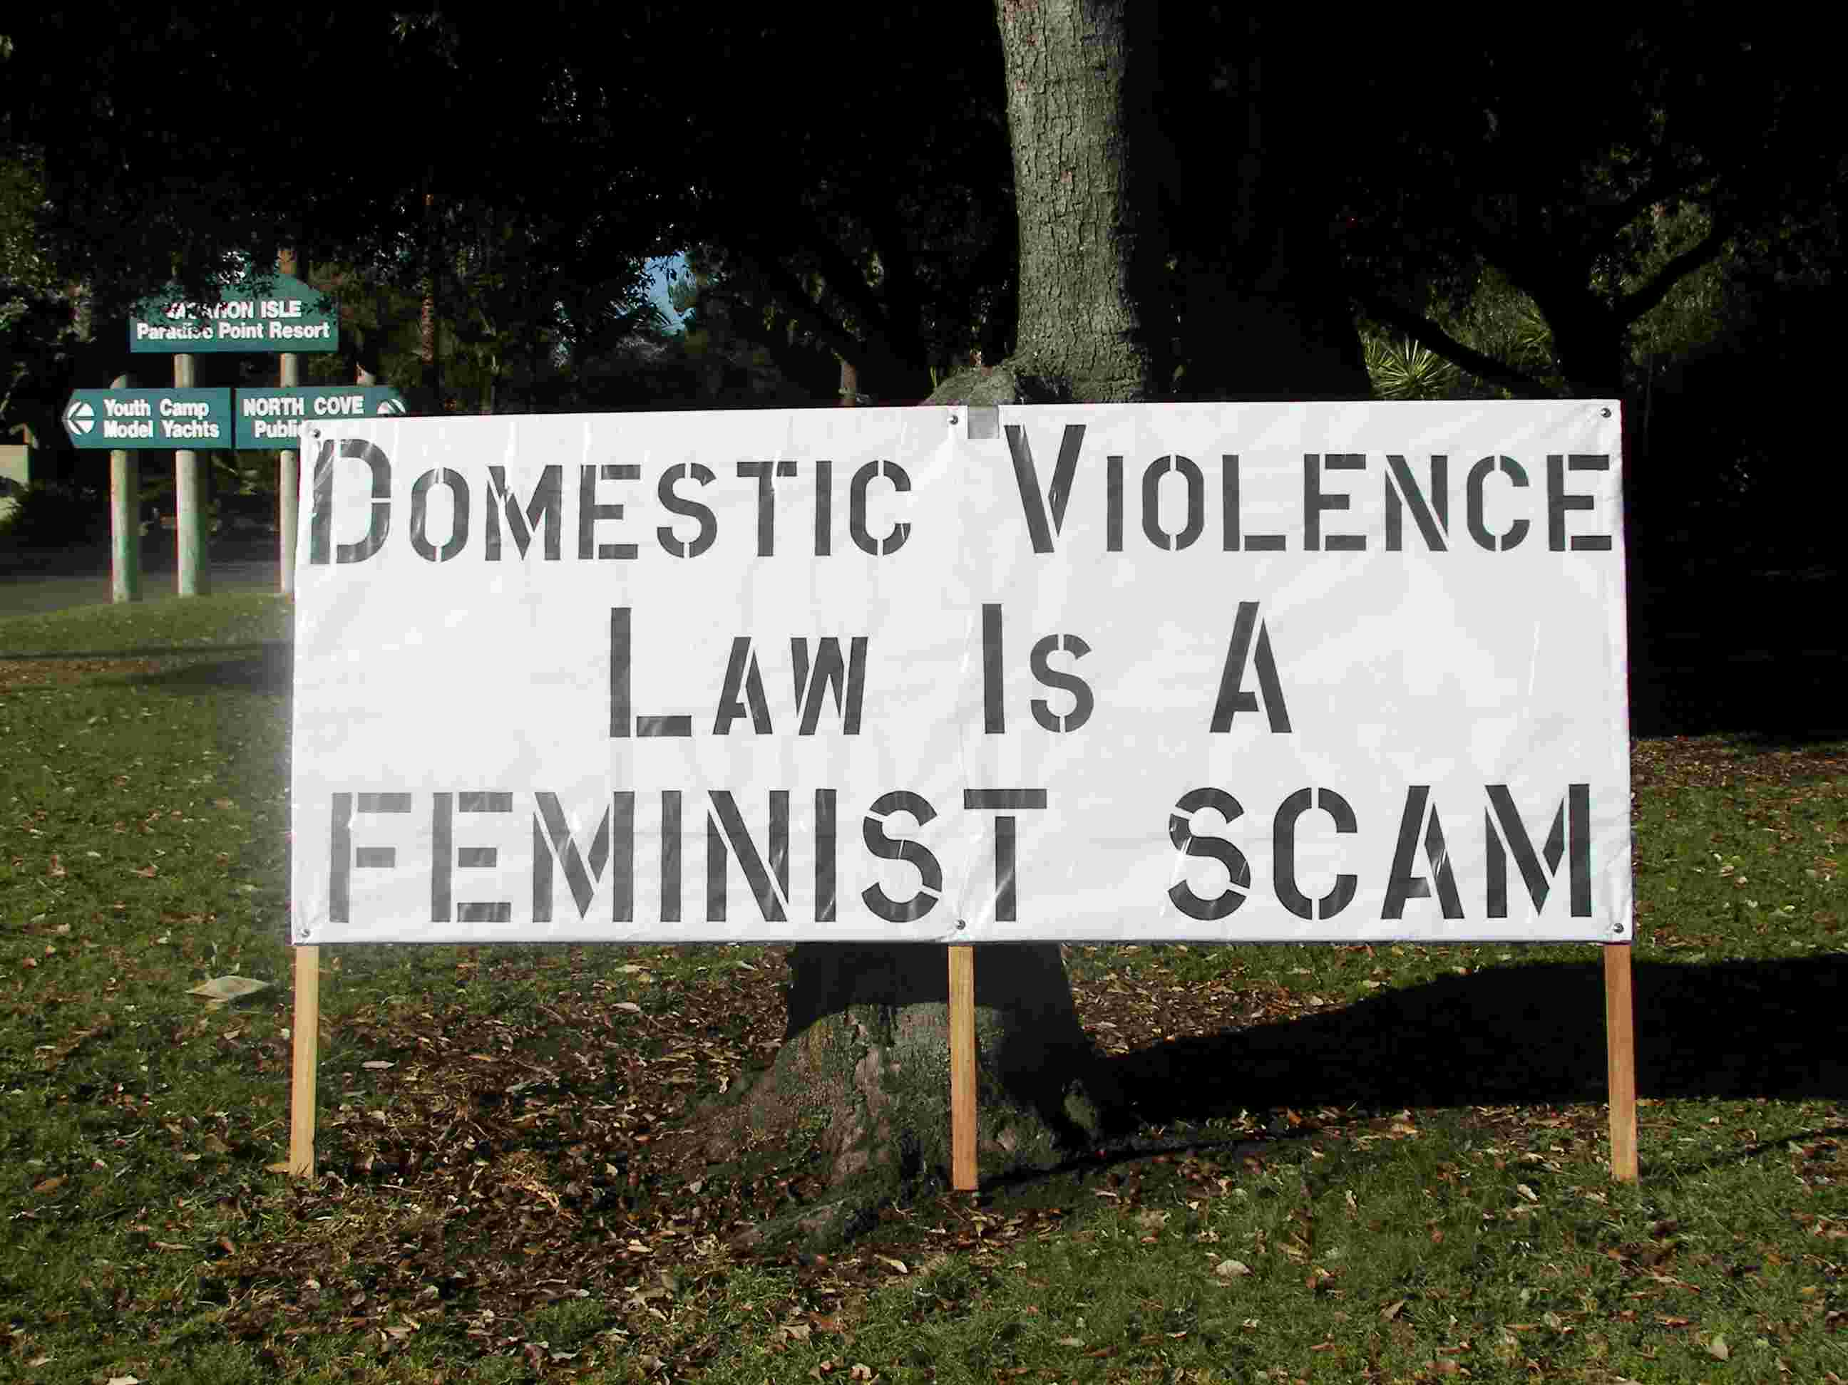
Despite this, sometimes men are denied custody for the wrong reason. Some are almost certainly convicted using false evidence. Perhaps some courts are biased against men. This doesn’t change the fact that in general, men are favored over women. Victims of domestic violence and sexual assault are subject every day to dual arrest, arrest of the victim only, false prosecution and criminal justice harassment. Despite the many gains made by enlightened members of the criminal justice system, my voice usually carries more weight there than does a woman’s. This is the true conspiracy – one that all genders need to work to change.

Strategy: Our state coalitions and national groups have well-researched data about the criminal justice system, child custody decisions, etc. Furthermore, ground-breaking films such as Breaking the Silence illustrate the horror and reality that battered moms face in some family courts. The real bias is against women, and the facts and anecdotes clearly support this.

Myth #4: “Father’s Rights” Groups Speak for All Fathers and for All Men

Reality #4: Most places I go, men care about girls and women. They want to become a part of the solution – with minimal education, and some tricks to get past male defensiveness, men literally line up to sign up.

I end every performance of “Voices of Men” by asking men in the audience to stand and take a pledge. In San Diego, hundreds of men, many of them military men in uniform, stood when I asked them to. A booming chorus of male voices pledged to “never commit, condone, or remain silent about men’s violence against women,” and to “respect, listen to, seek equality with and share power with every person I date, and every person I know.” These men were not fooled by the signs outside. The signs do not speak to them, nor did they believe them.

Strategy: We need to continue to organize men to ally themselves with our movement. These men should be on a “rapid response” email list, ready to come to our State Houses wearing suits and ties. These men should be ready to echo the sentiments that battered women’s advocates say, and to stand behind them if needed.

Some groups are already in place – most notably Joe Kelly and “Dads and Daughters,” www.dadsanddaughters.com. Kelly and other dads encourage fathers to work to end sexism and violence against girls and women, for their daughters’ sake as much as their own. The White Ribbon Campaign www.whiteribbon.com is an international movement of men to end men’s violence against women. And the National Organization for Men Against Sexism www.nomas.org organizes annual conferences to end sexism, racism, homophobia – they work to enhance men’s lives by (among other things) encouraging them to take a stand against men’s violence.

Many, many local and statewide groups exist that organize men to take a stand against men’s violence. I have been to many such communities - most of them have followed a simple five-step process which I will outline in a subsequent article. It is possible to organize men in our communities, without taking resources away from victim safety. And when each of our shelters, state coalitions and national groups has hundreds of men accountable to women’s leadership, the words of the “Father’s Rights” groups will ring hollow.

Long Term: Potential Allies?

Our primary concern in doing this work is usually the safety of battered women and their advocates. If the “Father’s Rights” groups have their way, this safety will be threatened – in addition, some of the “Father’s Rights” members can be and are very dangerous. For this reason, I urge our local programs and state coalitions to plan and strategize for existing and potential “Father’s Rights” activism in our communities and in our states – using this article if you find it useful.

But we must also remember that underneath every “Father’s Rights” member is a human being. As we learn more about these movements, their methods and their rhetoric, we can learn about the individual men and women involved. We can connect with these men and women – they are real people who have mostly been brainwashed. Some men of conscience I know, including my hosts in San Diego, are attempting to make real connections with these folks.

In the article referenced below, Alan Berkowitz says, "What men think other men think and do is one of the strongest determinants of how men act - even when these perceptions and beliefs are mistaken." “Father’s Rights” members have joined a movement that seemed most inviting to them, the one that seemed to address their concerns. But our movement addresses concerns of parental equality and partnership much more thoroughly than does theirs.

Like the Moral Majority and the Promise Keepers, their movement will eventually wane and might sputter out. When it does, they may find the feminist movement against domestic violence is the place they can go to build a world truly free from violence against women, children – and men.

Ben Atherton-Zeman is a feminist, actor and husband living in Acton, MA: He can be reached at benazeman@hotmail.com, or www.voicesofmen.org.

*************************************************************************************

Resources: Conflict Tactics Scale:

Surveys that use the CTS will count the raw number of violent acts committed while ignoring the reasons why people use violence. They ignore the context, motivations, meanings, and consequences of intimate partner violence. In fact, an examination of the data available to date reveals that the
majority of women who use violence against their male partners are battered themselves. While men generally use violence in order to control their female partners, many scholars and victim advocates report that women have different motivations for using force against their current or former
intimate partners. Women's abusive behaviors towards their heterosexual partners are motivated by several factors including self-defense and retaliation (see "Towards an Understanding of Women's Use of Non-Lethal Violence in Intimate Heterosexual Relationships").
Male Victims

"Men living with male intimate partners experience more intimate partner violence than do men who live with female intimate partners. Approximately 23 percent of the men, who had lived with a man as a couple, reported being raped, physically assaulted, and/or stalked by a male cohabitant, while 7.4
percent of the men, who had married or lived with a woman as a couple, reported such violence by a wife or female cohabitant. These findings provide evidence indicating that intimate partner violence is perpetrated primarily by men, whether against male or female intimates. Thus, strategies for
preventing intimate partner violence should focus on risks posed by men." [Tjaden, P. & Thoennes, N. (July 2000). Extent, nature, and consequences of intimate partner violence - findings from the National Violence Against Women Survey. (Publication #NCJ181867). National Institute of Justice and
the Centers for Disease Control and Prevention. Washington, DC: Office of Justice Programs.]
Violence Against Women Act

Funds are available under the Violence Against Women Act for services provided to victims regardless of gender. And while male victims represent a small parcel of the total number of clients, domestic violence programs nationwide provide crisis services to these victims as well. (see the "National Census of Domestic Violence Services" for a snapshot of the services provided by gender to adults.)
(Not all of the resources below are available on VAWnet, but most are.)
Articles:
Measuring the Extent of Woman Abuse in Intimate Heterosexual Relationships: A Critique of the Conflict Tactics Scales by Walter DeKeseredy and Martin Schwartz
http://new.vawnet.org/category/Documents.php?docid=388
Towards an Understanding of Women's Use of Non-Lethal Violence in Intimate Heterosexual Relationships by Shamita Das Dasgupta
http://new.vawnet.org/category/Documents.php?docid=410
Are Heterosexual Men Also Victims of Intimate Partner Abuse? by Joanne Belknap and Heather Melton
http://new.vawnet.org/category/Documents.php?docid=370
Male Victims of Domestic Violence: A Substantive and Methodological Research Review by Michael S. Kimmel
http://new.vawnet.org/category/Documents.php?docid=595
Husband Abuse: An Overview of Research and Perspectives by Leslie Tutty
http://new.vawnet.org/category/Documents.php?docid=942
Abuse in Gay Male Relationships: A Discussion Paper by Kevin Kirkland
http://new.vawnet.org/category/Documents.php?docid=938
Statistics:
Male Victims of Violence Facts
http://www.ncadv.org/files/malevictimsofviolence.pdf
Intimate Partner Violence: Fact Sheet
http://www.cdc.gov/ncipc/factsheets/ipvfacts.htm
Intimate Partner Violence in the United States
http://www.ojp.usdoj.gov/bjs/intimate/ipv.htm
Full Report of the Prevalence, Incidence, and Consequences of Violence Against Women
http://new.vawnet.org/category/Documents.php?docid=596
Extent, Nature, and Consequences of Intimate Partner Violence: Findings From the National Violence Against Women Survey
http://new.vawnet.org/category/Documents.php?docid=592
Domestic Violence Counts: The National Census of Domestic Violence Services - Communities and Individuals Served
http://www.nnedv.org/census/DVCounts2006/DVCounts06_App4_CommunitiesIndivServed.pdf
Women's Experiences of Abuse as a Risk Factor for Incarceration by Mary E Gilfus
http://new.vawnet.org/category/Documents.php?docid=412
Child Custody and Visitation Decisions in Domestic Violence Cases: Legal Trends, Research Findings, and Recommendations by Daniel G. Saunders
http://new.vawnet.org/category/Documents.php?docid=371
The Social Norms Approach to Violence Prevention by Alan D. Berkowitz
http://new.vawnet.org/category/Documents.php?docid=969
Two steps forward, one step back: Community attitudes to violence against women by Victorian Health Promotion Foundation (VicHealth)
http://new.vawnet.org/category/Documents.php?docid=630

